MTH2010 Readings and Assignments: Week 2
Week 2 Readings
As early in the week as possible, please read:
- Week 2 online lectures.
- The following sections from Chapter 2 (Parallel Lines) and Chapter 3 (Triangles) of the text Elementary Geometry:
  - Section 2.1 - pg. 72,
  - Section 2.2 - pg 80,
  - Section 2.3 - pg 86,
  - Section 2.4 - pg 93,
  - Section 2.5 - pg 99,
  - Section 3.1 - pg 128
  - Section 3.2 - pg 138
  - Section 3.3 - pg 145.
Week 2 Assignments Overview
Assignment Summary Week 2: | Due Date
Assignment 1: Discussion Questions | Friday, February 27, 2009
Assignment 2: Exam | Sunday, March 1, 2009
Assignment 3: Discussion on Exam | Tuesday, March 3, 2009
Assignment 4: Team Activity | Tuesday, March 3, 2009
Using the navigation on the left, please proceed to the next page.

Week 2

Learning Outcomes:
• Differentiate perpendicular and parallel lines.
• Find the angles of a triangle.
• Define convex polygons.
• Find the interior and exterior angles of a polygon.
• Identify congruent triangles and their properties.
• Identify different types of triangles and their properties.

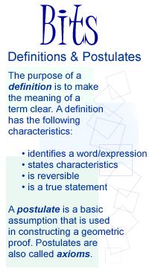
Definitions and Postulates
This week, we will be looking into parallel lines, perpendicular lines, and angles. Before we do that, let us first review the terms definitions and postulates. In geometry, you will frequently be looking at definitions and you will be using many postulates, especially in your geometric proofs.
The purpose of a definition is to make the meaning of a term clear. It usually will identify the word (or expression) that is being defined. It states the distinguishing characteristics of the term being defined, using only words that are commonly understood or that have been previously defined. And, a definition must be expressed in a grammatically correct sentence. Much of geometry involves building on previously discussed ideas. As an example, we can use terms that have been defined to arrive at a definition of another. Suppose we wanted to write the definition of a triangle. We can then use previously defined terms, i.e., in this case, the term noncollinear. We have the definition of collinear and noncollinear points to be as follows:
- Collinear points are points that lie on the same line.
- Noncollinear points are points that do not lie on the same line.
When we draw a triangle, we usually start with three noncollinear points and connect them with line segments. Hence, we have the definition of triangle to be as follows: 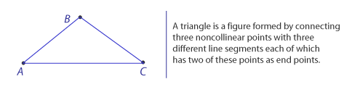
It is also important for a definition to be reversible. For example, if we say, "A right angle is an angle whose measure is 90 degrees" then the reverse, "An angle whose measure is 90 degrees is a right angle," has to be a true statement too. If the reverse is false, then the statement is not a good definition. Reversible definitions are useful in geometry when we try to establish properties of lines, segments, angles, and figures. For example, a midpoint of a segment is defined as a point that divides a segment into two segments of equal length. To prove that the point is actually the midpoint, we can use the reverse of the definition: a point that divides a segment into two segments of equal length is the midpoint of the segment. If we can show that the two segments are of equal length, then we can conclude that the point is indeed the midpoint for the segment. Another illustration would be the following:
We can define an even integer as an integer that leaves 0 as remainder when divided by 2. So, how can we prove that a particular integer is an even number? We can use the reverse of the definition to show that when an integer is divided by 2, the remainder is 0. If this is true, then the integer must be an even number.
Postulates (or axioms) are basic assumptions that can be used in geometric proofs. As you read your textbook, you will come across many postulates.This week, you will be looking into parallel postulates and proving that lines are parallel.

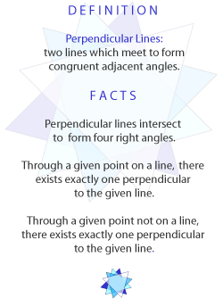
Parallel Lines and Perpendicular Lines
Lines in a plane either intersect or are parallel. Line segments that lie in the same plane (i.e. coplanar lines), if extended indefinitely, will eventually either intersect or never meet. Two lines are said to be perpendicular if they intersect to form a right angle. By definition, two lines are perpendicular if they meet to form congruent adjacent angles. We can then state the facts on perpendiculars to be:
- Perpendicular lines intersect to form four right angles.
- Through a given point on a line, there exists exactly one perpendicular to the given line.
- Through a given point not on a line, there exists exactly one perpendicular to the given line.
To prove that two lines are perpendicular:
- Show that the lines intersect to form a right angle
- Show that the lines intersect to form a pair of congruent adjacent angles.
Here is how you would provide proof without using a diagram or construction as shown in your text.
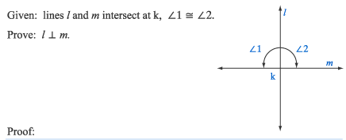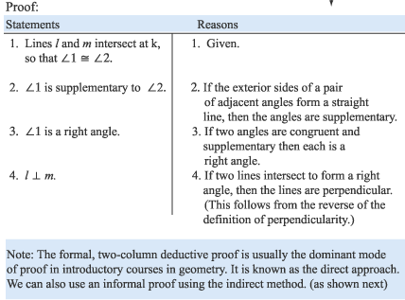

Informal Proof:
To illustrate an informal proof:
Using the postulate "Exactly one line may be drawn between two given points," use an indirect method of proof to establish the theorem that says 'If two lines intersect, then they intersect in exactly one point."
Solution:
Let lines l and m represent the intersecting lines. There are two possibilities: 1) the lines intersect exactly at one point, and 2) they intersect in more than one point. Assume the latter is true and the lines intersect in two points, lets say P and T. This implies that both lines l and m pass through P and T, contradicting Postulate 1 which infers that one and only one line may be drawn between two points. Therefore, the remaining conclusion—that there is exactly one point of intersection—must be true.

Parallel Lines
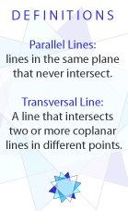
Lines that never intersect are defined to be parallel. Lines drawn on a sheet of note paper, wire strung on telephone polls, lines drawn to mark yards on a football field, are all examples of parallel lines.
The symbol that we use for parallel lines is ||. So if we say line l is parallel to line m, we write l || m. By definition, parallel lines are lines in the same plane that never intersect. It follows then that portions (segments or rays) of parallel lines are parallel, and extensions of parallel segments or rays are parallel as well. Refer to your text on some of the parallel postulates.
Note: A line that intersects two or more lines in different points is called a transversal line. The angles that are formed include interior angles and exterior angles.
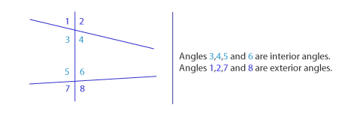
If two lines are parallel and they are cut by a transversal, than the corresponding angles formed have equal measures, i.e. they are congruent. In addition, the alternate interior angles are congruent and so are the alternate exterior angles. The two interior angles on the same side of the transversal are supplementary angles. Please refer to your text for formal proofs on this.

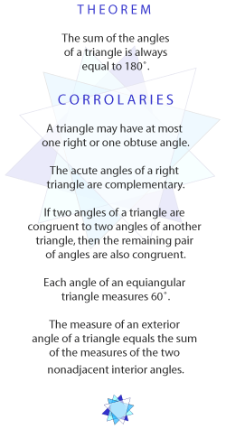
Triangles
A triangle is the simplest type of polygon. There are different types of triangles and they can be categorized based on the length of their sides or by the angles in the triangle. Make sure you become familiar with and know what its means to have a scalene, isosceles, or equilateral triangle. In addition, we have the acute triangle, obtuse triangle, right triangle, and equiangular triangle. Please refer to your text for the illustrations.
There are some angle-sum relationships in a triangle that exists and can be generalize to other polygons as well. Let us first look at the triangle and its angles. One of the most familiar geometric relationships is, as stated in theorem 2.4.1 in your text: The sum of the measures of the angles in a triangle is 180 degrees. And with that in mind, you can then solve algebra problems related to angles in a triangle. From this theorem, we have what we call corollaries of the angle-sum theorem. Note: A corollary is a theorem that is closely related to a previously proved theorem.
The corollaries of the triangle angle-sum theorem include:
- A triangle may have at most one right or one obtuse angle.
- The acute angles of a right triangle are complementary.
- If two angles of a triangle are congruent to two angles of another triangle, then the remaining pair of angles are also congruent
- Each angle of an equiangular triangle measures 60
- The measure of an exterior angle of a triangle equals the sum of the measures of the two nonadjacent interior angles.

Congruent Triangles
Triangles that can be made to coincide by placing one on top of the other are said to be congruent. By definition, two triangles are congruent when the six parts of the first triangle are congruent to the six corresponding parts of the second triangle.
Definitions of corresponding parts of triangles are given as follows:
- Corresponding angles are pairs of angles whose vertices are paired in a given correspondence between two triangles.
- Corresponding sides are pairs of segments whose end points are vertices that are paired in a given correspondence between two triangles. Corresponding sides of triangles lie opposite corresponding angles.
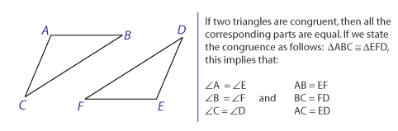
How can we tell that two triangles are congruent? Do we have to know that all the sides and all the angles of one triangle are congruent to the corresponding parts of a second triangle before we can conclude that the two triangles are congruent? Given certain facts about the triangles, we can try to prove that the triangles are congruent and there are shortcut methods for doing this, rather than trying to demonstrate that they are the same in six pairs of parts. Your book illustrates the different methods starting on page 104. To summarize, you may conclude that two triangles are congruent if you can show that:
- Three sides of one triangle are congruent to the corresponding parts of the other triangle. (Method: SSS postulate)
- Two sides and the included angle of one triangle are congruent to the corresponding parts of the other triangle (Method: SAS postulate)
- Two angles and the included side of one triangle are congruent to the corresponding parts of the other triangle (Method: ASA postulate)
- Two angles and the side opposite one of them are congruent to the corresponding parts of the other triangle (Method: AAS theorem)

You may conclude that two right triangles are congruent if the hypotenuse and either leg of one triangle are congruent to the corresponding parts of the other right triangle. (Method:Hy-Leg Postulate)
You may not however conclude that two triangles are congruent when:
- Two sides and an angle that is not included of one triangle are congruent to the corresponding parts of the other triangle.
- Three angles of one triangle are congruent tot the corresponding parts of the other triangle.

Be sure you understand the examples shown in your textbook readings this week.
Assignment 1: Discussion Questions
By Friday, February 27, 2009 choose two of the discussion questions, and post your responses in the Discussion Area. Your response should reflect an understanding of the material covered as it applies to your life, work, and educational experiences. Start reviewing and responding to your classmates as early in the week as possible; post comments on at least two of your classmates' submissions to the Discussion Area. Please refer to the policy for participation found in the Educational Commitment Statement.
Grading Criteria | Maximum Points
Correct explanation of concepts. | 4
Correct examples provided | 4
Well-formed conclusions. | 4
Participation in discussion with class, feedback, and comments. | 4
Correct spelling and grammar. | 4
Total: | 20
For assistance with any problems you may have when completing this assignment—OR—to offer your assistance to classmates, please use the Problems and Solutions Discussion area located through the left side navigation link.
DQ 1 - Explain the differences between parallel lines and perpendicular lines and state their postulates.
DQ2 - What is a polygon? What is the difference between an equiangular polygon, an equilateral polygon, and a regular polygon? Provide an example of each.
DQ3 - Discuss the different methods that we can use for proving triangles congruent.
Assignment 3: Discussion on Quiz
Your facilitator will assign four questions from the Week 2 quiz; by Tuesday, March 3, 2009, present to the class how you solved these questions. Post your responses to this Discussion Area.
Review and critique the work of at least two other students by the end of the week and post your comments to the Discussion Area.
Grading Criteria | Maximum Points
The solutions present show understanding of concept. | 4
Participation and feedback. | 4
Total: | 8
For assistance with any problems you may have when completing this assignment—OR—to offer your assistance to classmates, please use the Problems and Solutions Discussion area located through the left side navigation link.

By Tuesday, March 3, 2009 (Day 6), look at the questions 1, 6, 7, an 12 in the Week 2 exam. Post your responses to all four of these questions to the Discussion Area. Review and critique the work of at least two other students by the end of the week and post your comments to this Discussion Area.
One way to attach your answers is to this thread is to type them into this textbox. Consider this method, it makes your work easily viewable and right there for everyone to see. Scanning is also an option, as are pdf's and Word documents. Make sure your work is legible, well organized, and all scans clear.
You will be asked to resubmit your work if your work is not legible and cannot be graded. Also, make sure your name appears at the top of your document.

Quiz Problems 1 and 12
1. A regular polygon has 12 sides. What will be the measure of each interior angle of the polygon if each angle has equal measure? (Points: 1)
156 degrees
150 degrees
160 degrees
164 degrees
12. If the sum of all the interior angles of a polygon is 1800, how many sides does the polygon have? (Points: 1)
16
18
20
None of these

